INDIAN SCHOOL AL WADI AL KABIR
TERM 1: Chapter 6- The challenges of Cultural Diversity (GRADE XII)
NOTES AND Q&A

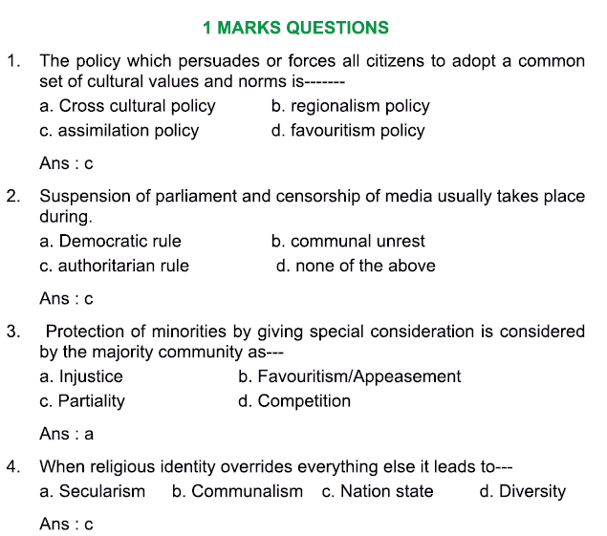
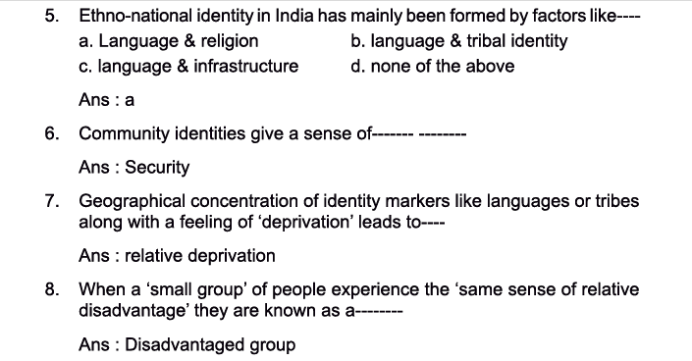
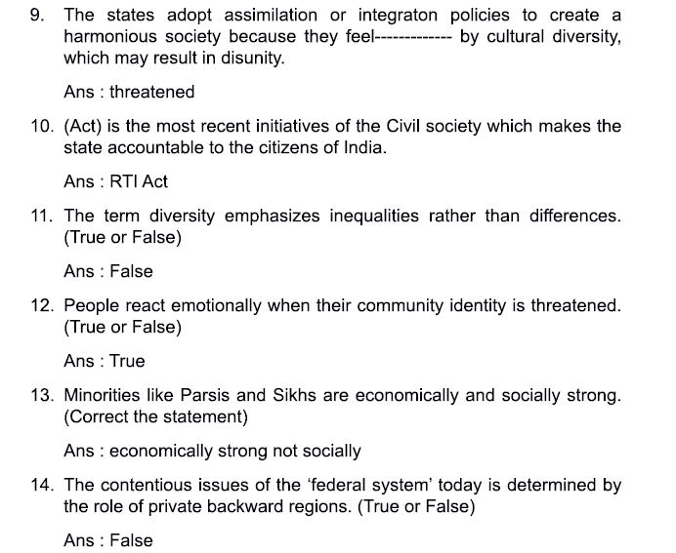
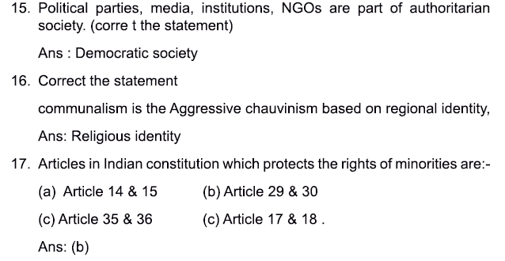
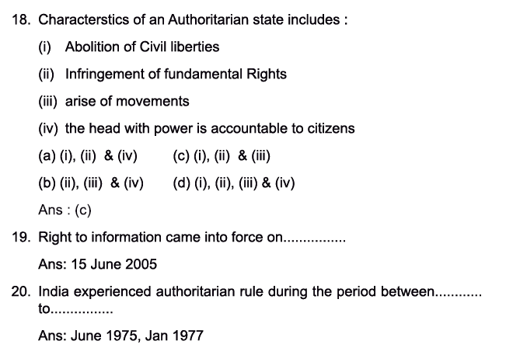

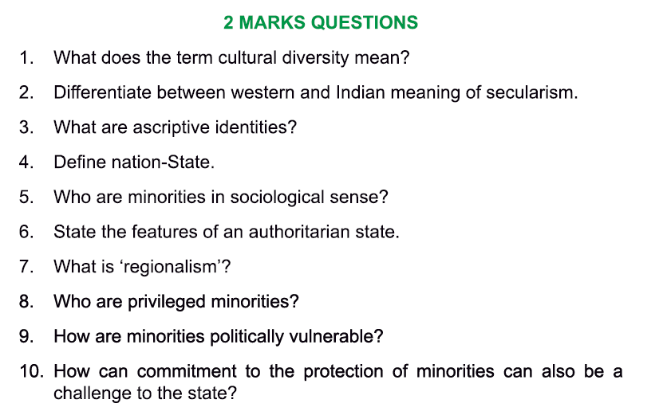
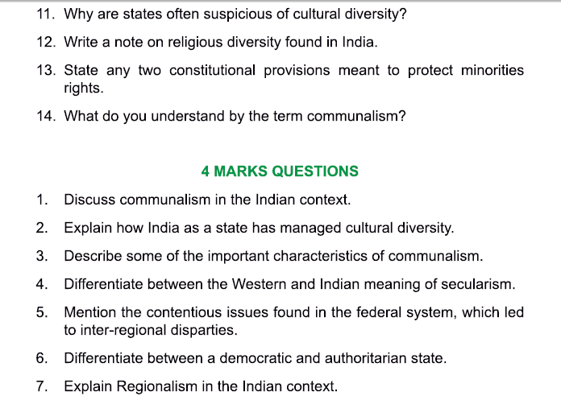
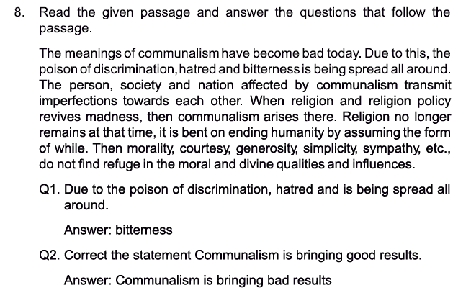
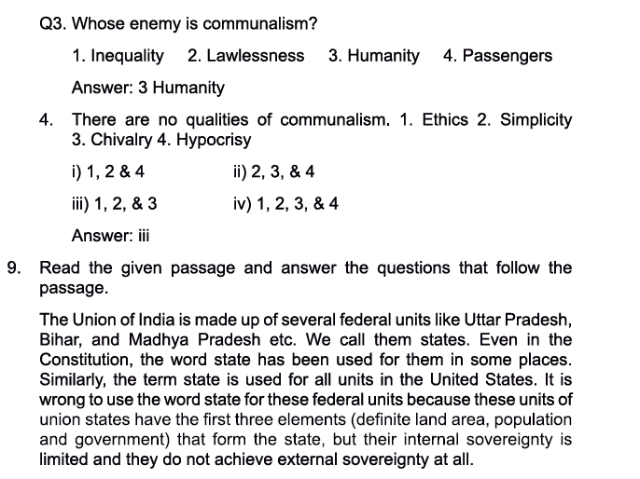
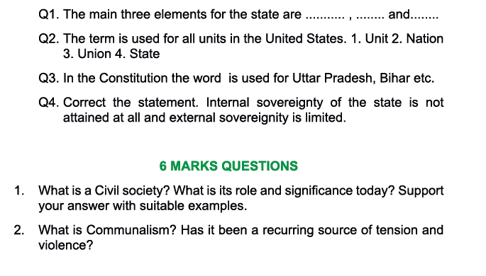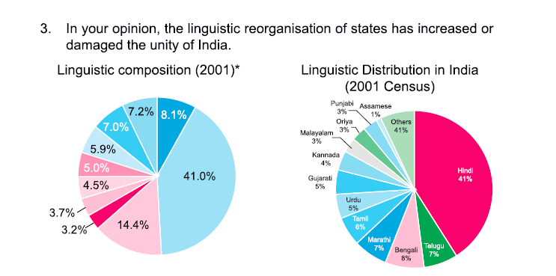
ANSWERS TO 2 MARK QUESTIONS:
1. What does the term cultural diversity mean?
The term diversity implies differences rather than inequalities. When we say that India is a nation of great cultural diversity, we mean that there are many different types of social groups and communities living here. There are communities with different cultural markers like language, religion, sect, race or caste.

2. Differentiate between western and Indian meaning of secularism
Western meaning -
· Separation of church and state.
· Separation of religious and political authority.
· Related to the arrival of modernity and the rise of science and rationality.

Indian meaning -
· Secular state / person is one that doesn’t favour any particular religion over others.
· Equal respect for all religions, rather than separation and distancing.

3. What are ascriptive identities?
Community identities are based on birth and ‘belonging’ rather than on some form of acquired qualifications or ‘accomplishment’ are called ascriptive identities. It is what we ‘are’ rather than what we have ‘become’. There are 2 features to ascriptive identities:
-These kinds of ascriptive identities are determined by the birth and do not involve any choice on the part of the individuals concerned.
-A second feature of ascriptive identities and community feeling is that they are universal. Everyone has a motherland, a mother tongue, a family, a faith. This may not necessarily be strictly true of every individual, but it is true in a general sense.

4. Define nation-states
A nation is a large-scale community consisting of different communities. A state on the other hand refers to an abstract entity consisting of a set of political-legal institutions claiming control over a particular geographical territory and people living in it. Nation -states are thereby communities that have a state of their own in the modern world.

5. Who are minorities in a sociological sense? (Give examples and add more to this answer)

Minorities in the sociological sense involve some sense of relative disadvantage. The sociological sense of minority implies that the members of the minority form a collectivity i.e. they have a strong sense of group solidarity, a feeling of togetherness and belonging. Minorities may be subjected to prejudice and discrimination too.

6. State the features of an authoritarian state?
An Authoritarian state is a state in which the people have no voice and those in power are not accountable to anyone. Features of an authoritarian state are as follows: Authoritarian states often limit or abolish civil liberties like freedom of speech, freedom of the press, freedom of political activity, right to protection from wrongful use of authority, right to the due processes of the law, and so on.

7. What is 'regionalism '?

• Regionalism in India is rooted in India’s diversity of languages, cultures, tribes and religions.
•It is encouraged by the geographical concentration of these identity markers in particular regions, and fueled by a sense of regional deprivation.
8. Who are privileged minorities?
A minority usually involves some sort of a relative depravation. A minority group can be disadvantaged in one sense but not in another. For example, religious minorities like Parsis and Sikhs may be relatively well- off economically. But may be disadvantaged in a cultural sense because of small numbers.

9. How are minorities politically vulnerable?
In democratic politics, it is always possible to convert a numerical majority into political power through elections. This means that religious or cultural minorities are politically vulnerable. In addition to this, minorities also face the risk that the majority community will capture political power and use the state machinery to suppress their religious and cultural institutions, ultimately forcing them to abandon their distinctive cultural identity.

10. How can commitment to minorities also be a challenge for the state?
Write on your own from textbook
11. Why are states often suspicious of cultural diversity?
• States try to establish their political legitimacy through nation-building strategies.
•They seek to secure the loyalty and obedience of their citizens through policies of assimilation or integration partly due to the fact that most states have generally been suspicious of cultural diversity and have tried to reduce or eliminate it. The states fear that the recognition of varied culturally diverse identities such as language, ethnicity, religion will lead to social fragmentation and prevent the creation of a harmonious society.
12. Write a note on religious diversity found in India?

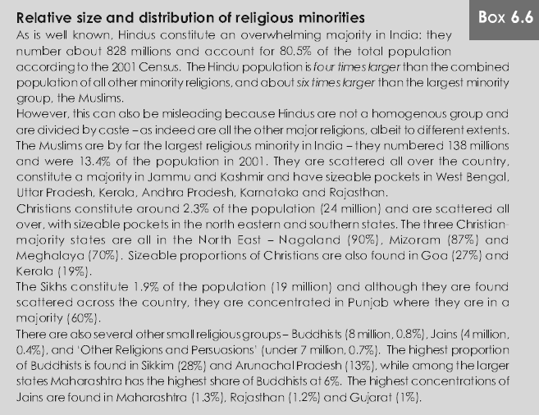

13. State any two constitutional provisions meant to protect the rights of minorities. Rushi
Article 29 and 30 are part of the Indian Constitution with special reference to Minorities and Cultural Diversity.

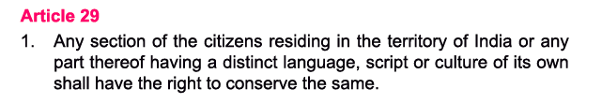
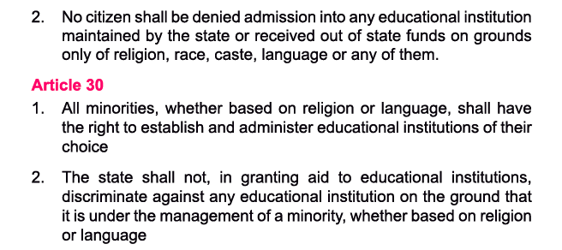

14. What do you understand by the term communalism?

Communalism refers to aggressive chauvinism based on religious identity. Chauvinism is itself an attitude that sees one’s own group as the only legitimate or worthy group, with other groups being seen as inferior, illegitimate and opposed.
•Communalism is an aggressive political ideology linked to religion.
•This is a peculiarly Indian or South Asian meaning which is different from the ordinary English word.
ANSWERS to 4-mark questions:
- How can communalism be a threat to the Indian state?
- Explain how India as a state has managed cultural diversity?
- Describe some important characteristics of communalism
- Mention the contentious issues in the federal state that led to the inter-regional disparities.
- Differentiate between democratic and authoritarian state

ANSWERS to 6-mark questions:
What is civil society? What is its role and significance today? Support your answer with suitable examples.

- Civil society is the non-state and non-market part of the public domain in which individuals get together voluntarily to create institutions and organizations.
- It is the sphere of active citizenship. Here, individuals try to take up social issues, try to influence the state or make demands on it, pursue their collective interests or seek support for a variety of causes.
- It consists of voluntary associations, organizations or institutions formed by groups of citizens, political parties, media institutions, trade unions, non-governmental organizations (NGOs).

- Today, the activities of civil society organizations have a wide range, including advocacy and lobbying activity with national and international agencies as well as active participation in various movements.

- Diverse issues taken up by civil society -
- Tribal struggles for land rights
- Devolution in urban governance
- Campagins against rape and violence
- Rehabilitation of those displaced by dams and other developmental projects
- Fishermen’s struggles against merchandised fishing
- Rehabilitation of hawkers and pavement dwellers
- Campaigns against slum demolitions and for housing rights
- Primary education reform
- Distribution of land to dalits
- Keeping a watch on the state and forcing it to obey the law

- Among the most significant recent initiatives is the campaign for the Right to information. It illustrates the crucial role of civil society in ensuring that the state is accountable to its nations and its people. The answer to the RTI has to be given within 30 days.
- According to this act, any person can demand allocation of funds, tax from the government and copy the fund document.
- People have the right to get information about the allocation of funds for various projects.
- Right to receive documents.
- Inspection of documents, works and records.
- Right to take certified samples of work materials ; to collect citizen information through printouts, discs, floppy tapes, video cassettes and other electronic means.

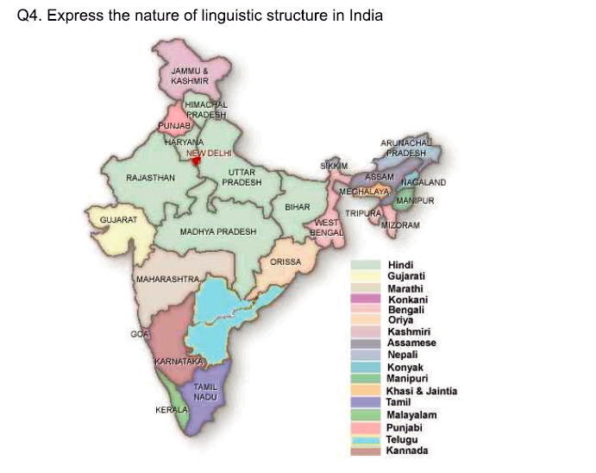

NCERT SOLUTIONS
1.What is meant by cultural diversity? Why is India considered to be a very diverse country?
Ans. • The term diversity implies differences rather than inequalities.
•When we say that India is a nation of great cultural diversity, we mean that there are many different types of social groups and communities living here.
•Different types of social groups and communities live here. There are communities with different cultural markers like language, religion, sect, race or caste.
•India is a pluralistic society. There is unity in diversity but its excessive diversity is becoming a challenge.
•When diverse communities (linguistic communities, religious communities, sects and so on) are, also, a part of a larger entity like a nation, then difficulties may be created by competition or conflict between them.
•Cultural diversity can present challenges which arise from the fact that cultural identities are very powerful-they can arouse intense passions and are often able to mobilize large numbers of people.
•Sometimes, cultural differences are accompanied by economic and social inequalities and this further complicates things.
•Measures to address the inequalities or injustices suffered by one community can provoke opposition from other communities. The situation gets worse when scarce resources like water, jobs or government
funds have to be shared.
•1632 different languages and dialects, different religions, diversity in climatic conditions and topography are causing serious challenges to the country.
2. What is community identity and how is it formed?
Ans. 1.Community identity is based on birth and belonging rather than on some forms of acquired qualifications or accomplishments.
2.These kind of identities are called ascriptive i.e. they are determined by birth and individual’s choice is not involved.
3.People feel a deep*sense of security and satisfaction in belonging to communities.
4.Ascriptive identities such as community identities are difficult to shake off; even if we choose to disown them, others may continue to identify us by those very markers of belonging.
5.Expanding and overlapping circles of community ties like family, kinship, ethnicity, language give meaning to our world and gives us a sense of identity.
6.Ascriptive identities and community feelings are universal. Everyone has a motherland, a mother tongue, a family, a faith. And we all are equally committed to our respective identities.
7.Our community provides us with our mother-tongue and the cultural values through which we comprehend the world. It, also, anchors our self-identity.
8. The process of socialization involves continuous dialogue with our significant surroundings such as parents, kin, family and community. Thus, community is a very important part of our identity.
9. Community conflicts are very hard to deal with since each side thinks of the other side as a hated enemy and there is a tendency to exaggerate the virtues of one’s own side as well as the vices of the other side.
10.It is very hard for people on either side to sec that they are constructing matching but reversed mirror images of each other.
11.At times, both sides are indeed equally wrong or right; at other times, history may judge one side to be the aggressor and the other to be the victim.
12.But this can happen long after the heat of the conflict has cooled down.
13.Some notion of a mutually agreeable truth is hard to arrive at in situations if identity conflict.
3. Why is it difficult to define the nation? How are nation and state related in modern society?
Ans. • A nation is a peculiar sort of community that is easy to describe but hard to define.
•We can describe many nations founded on the basis of common cultural, historical institutions like a shared religion, language, ethnicity, history or regional culture.
•But it is hard to come up with any defining features for nation.
•For every possible criterion there are exceptions and counter examples.
•For example-there are many nations that do not share a common language, religion, ethnicity and so on. On the other hand, there are many languages, religions or ethnicities that are shared across nations. But this does not lead to the transformation of a single unified nation.
Nation at the simplest level, is a community of communities. Members of a nation share the desire to be a part of the same political collectivity. Nations are communities that have a state of their own.
•In modem times, there has been a one-to-one bond between nation and state. But this development is new.
•It wasn’t true of the past that a single state could represent a single nation or every nation must have its own state.
•For example, Soviet Union explicitly recognized that the peoples it governed were of different nations.
•Also, people constituting a nation may actually be citizens or residents of different states. There are more Jamaicans living outside Jamaica than in Jamaica.
•Dual citizenship could, also, be a possibility. These laws allow citizens of a particular state to also simultaneously be citizens of another state. Example, Jewish Americans may be citizens of Israel as well as the USA.
•Thus, nation is a community that has been able to acquire a state of its own. It‘s, also seen that states are finding it more and more necessary to claim that they represent a nation.
•A feature of the modern era is the establishment of democracy and nationalism as dominant sources of political legitimacy. This implies that nation is the most accepted or proper justification for a state, while people are the ultimate source of legitimacy of the nation.
4.Why are states often suspicious of cultural diversity?
Ans. • States try to establish their political legitimacy through nation-building strategies.
•They sought to secure the loyalty and obedience of their citizens through policies of assimilation or integration.
•This is because most states have generally been suspicious of cultural diversity and have tried to reduce or eliminate it. The states fear that the recognition of varied culturally diverse identities such as language, ethnicity, religion will lead to social fragmentation and prevent the creation of a harmonious society.
•Also, apart from the fear of fragmentation, accommodating these differences is politically challenging.
•Thus so many states have resorted to either suppressing these identities or ignoring them in the political domain.
5.What is regionalism? What factors is it usually based on?
Ans. • Regionalism in India is rooted in India’s diversity of languages, cultures, tribes and religions.
•It is encouraged by the geographical concentration of these identity markers in particular regions, and fuelled by a sense of regional deprivation.
•Indian federalism has been a means of accommodating these regional sentiments.
From Presidencies to States
•After Independence, initially the Indian state continued with the British-Indian arrangement dividing India into large provinces, called Presidencies. Madras, Bombay and Calcutta were the three major presidencies.
•Soon after Independence and the adoption of the constitution, all these units of the colonial era had to be reorganized into ethno-linguistic states within the Indian union in response to strong popular agitations.
•Language coupled with regional and tribal identity and not religion has provided the most powerful instrument for the formation of ethno-national identity in India.
•But this does not mean that all linguistic communities have got statehood. For example- Chhattisgarh, Uttarakhand and Jharkhand. In their formation, language did not play*any role. A combination of ethnicity based on tribal identity, language, regional deprivation and ecology provided the basis.
6. In your opinion, has the linguistic reorganisation of states helped or harmed India?
Ans. •Language coupled with regional and tribal identity-and not religion-has provided the most powerful instrument for the formation of ethno-national identity in India. Language ensures better communication and results in more effective administration.
•Madras presidency was divided into Madras State, Kerala and Mysore State. The Report of the States Reorganisation Commission (SRC) which was implemented on November 1, 1956, has helped transform the political and institutional life of the nation.
•It has proved to be perfectly consistent to be Kannadiga and Indian, Bengali and ’ Indian, Tamil an4 Indian, Gujarati and Indian.
•In 1953, Potti Sriramulu, died seven weeks after beginning a fast unto death. His death provoked violent protests and led to the creation of the state of Andhra Pradesh. It also led to the formation of the SRC, which in 1956 put the formal, final seal of approval on the principle of linguistic states. These states based on language sometimes quarrel with each other. While these disputes are not pretty, they could in fact have been far worse.
Currently there are 29 states (federal units) and 7 Union territories (centrally administered) within the Indian nation-state.
7. What is a ‘minority’? Why do minorities need protection from the state?
Ans. • Minority usually involves some sense of relative disadvantage.
•Privileged minorities such as extremely wealthy people are not usually referred to as minorities; if they are, the term is qualified in some way, as in the phrase “privileged minority’.
•When minority is used without any qualification, it implies a relatively small and also, disadvantaged group.
•The sociological sense of minority implies that the members of the minority form a collectivity i.e. they have a sense of group solidarity, a feeling of togetherness and belonging.
•This is linked to disadvantage because the experience of being subjected to prejudice and discrimination usually heightens feelings of intra-group loyalty and interests.
•Groups may be a minority in statistical sense, such as people who are left-handed or people born on 29th February, are not minorities in sociological sense because they do not form a collectivity.
•Religious or cultural minority groups need special protection because of the demographic dominance of majority.
•These groups are politically vulnerable. They must face the risk that the majority community will capture political power and use the state machinery to suppress their religious or cultural institutions, ultimately forcing them to abandon their identity.
Exceptions
•Religious minorities like Parsis or Sikhs may be relatively well off economically but they may still be disadvantaged in the cultural sense because of their small numbers compared to overwhelming majority Hindus.
•Another set of complications arise by the fact of India state’s simultaneous commitment to secularism as well as the protection of minorities.
•The protection of minorities requires that they be given special consideration in a context where the normal working of the political system places them at a disadvantage vis-s-vis the majority.
•This leads to the accusation of favouritism. But supporters would state that without this protection, secularism can turn into an excuse for imposing majority community’s values and norms on minorities.
8. What is Communalism?
Ans. • Communalism refers to aggressive chauvinism based on religious identity. Chauvinism is itself an attitude that sees one’s own group as the only legitimate or worthy group, with other groups being seen as inferior, illegitimate and opposed.
•Communalism is an aggressive political ideology linked to religion.
•This is a peculiarly Indian or South Asian meaning which is different from the ordinary English word.
•In the English language, ‘communal’ means something related to a community or collectivity as different from an individual. The English meaning is neutral, whereas the South Asian meaning is strongly charged.
•Communalism is about politics not about religion. Although, communalists are intensely involved with religion, there is no necessary relationship between personal belief and communalism. A communalist may or may not be a devout person, and devout persons may or may not be communalists.
•Communalists cultivate an aggressive political identity and are prepared to condemn or attack everyone who does not share their identity.
•One of the most important features of communalism is that religious identity overrides everything else, it, also, constructs large and diverse groups as singular and homogenous.
•Examples of communal riots in our country- Anti Sikh riots of 1984; the Gujarat riots.
•But, India also has a long tradition of religious pluralism, ranging from peaceful co-existence to actual mixing or syncretism. This syncretic heritage is reflected in the devotional songs and poetry of the Bhakti and Sufi movements.
9. What are the different senses in which ‘secularism’ has been understood in India?
Ans. 1. The Indian meanings of secular and secularism imply that state does not favour any religion. This implies equal respect for all religions rather than separation or distancing.
2. In the western context, secularism implies separation of church and state. This implies the progressive retreat of religion from public life, as it was converted from a mandatory obligation to a voluntary personal practice.
3. Secularization was related to the arrival of modernity and the rise of science and rationality as alternatives to religious ways of understanding the world.
4. One difficult issue that arises from this is the tension between the western sense of state maintaining distance from religion and the Indian sense of the state giving equal respect to all religions.
10. What is the relevance of civil society organisations today?
Ans. • Civil society is the name given to the arena which lies beyond the private domain of the family, but outside the domain of both state and market.
•Civil society is a non-state and non-market part of the public domain in which individuals get together voluntarily to create institutions and organisations.
•It is a sphere of active citizenship: individuals take up social issues, try to influence the state or make demands on it, pursue their collective interests or seek support for a variety of causes.
•It consists of voluntary institutions formed by group of citizens. It includes political parties; media institutions, trade unions, NGOs, religious organisations and other kinds of collective entities.
•The main criteria for inclusion in civil society are that the organisation should not be state controlled, and it should not be purely profit-making entity.
•Examples-Doordarshan is not a civil society entity though private television channels are. The Indian people had an encounter with authoritarian rule during ‘Emergency’ enforced between June 1975 and 1977. Forced sterilization programmes; censorship on media and government officials; civil liberties revoked.
Civil Society Today
•Today the activists of civil society organizations have a wide range of issues including advocacy and lobbying activity with national and international agencies as well as active participation in various movements.
•The issues taken jip range from tribal struggles for land rights; devolution of urban governance; campaigns against rape and violence against women, primary education reform, etc.
•Media, also, has started to play an important role in the civil society initiatives.
•Example-the Right to Information. Beginning with an agitation in rural Rajasthan for the release of information on government funds spent on village development, this effort grew into a nation-wide campaign. Despite opposition from the bureaucracy. Government was forced to respond to the campaign and pass a new law formally acknowledging citizens’ right to information.
